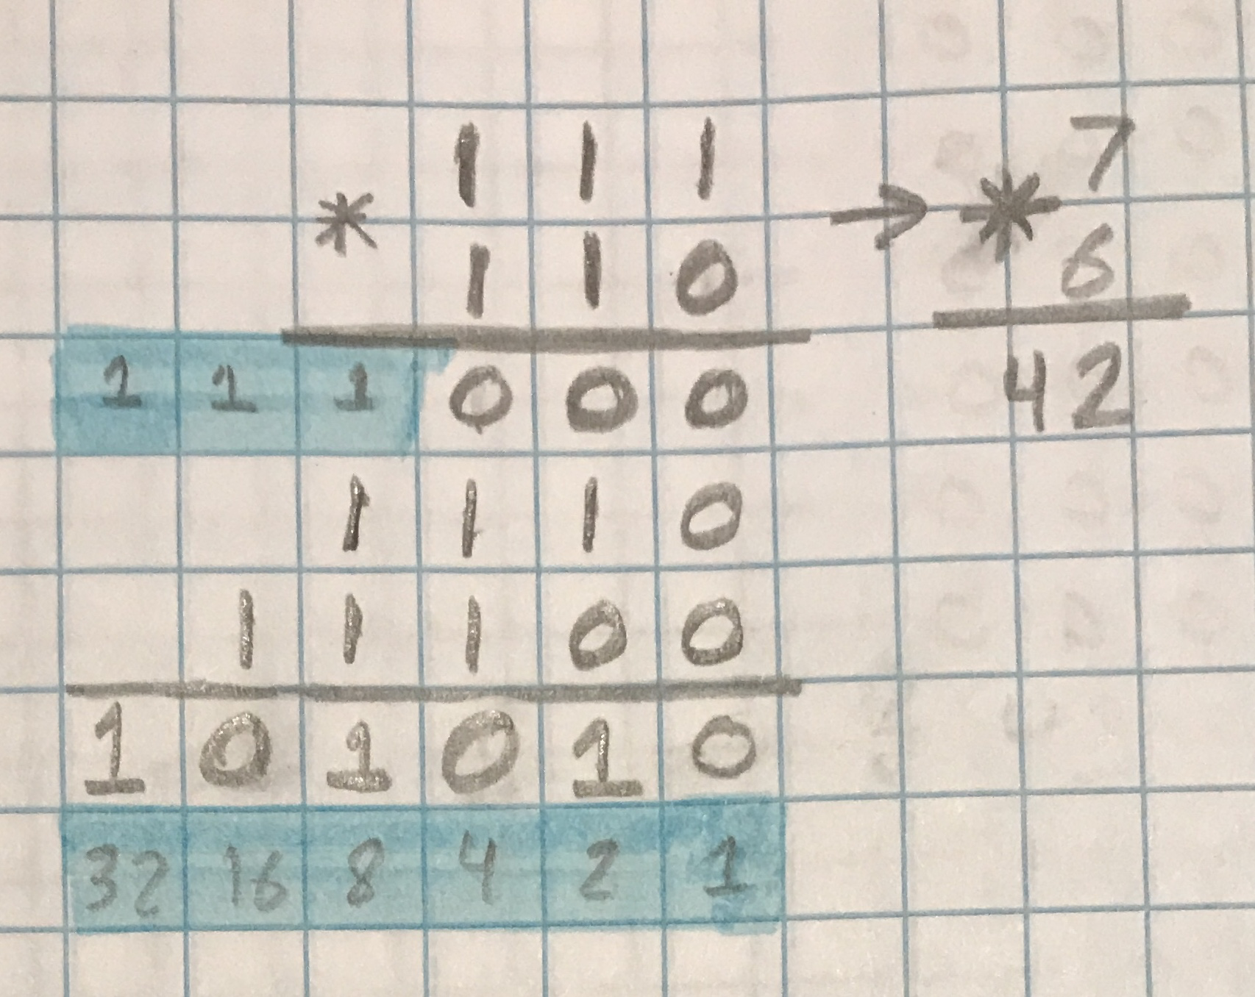

The picture above shows a basic example of multiplying a 3-bit binary number with another 3-bit binary number. The highlighted areas in blue show the carried bits and the powers of 2 represented by the position of a bit within a binary number.

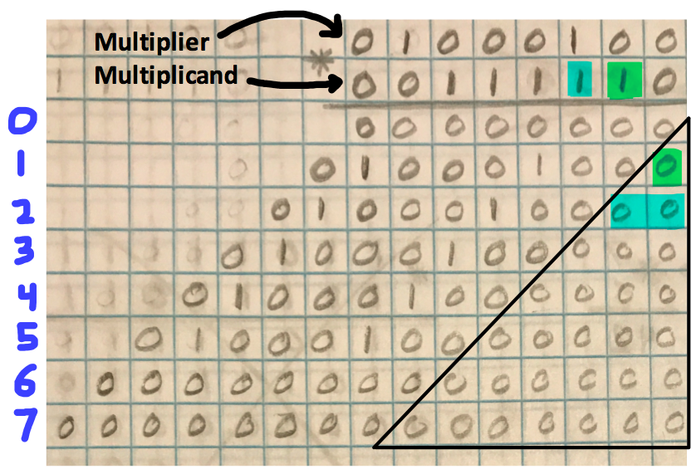

In the above picture, the number of zeros increases as you go down the rows. This is because of the multiplication procedure in itself, which requires that the number of zeros must match the number of place values shifted in the multiplicand. For example, in the green, the multiplier is multiplied to the bit that is located in the first bit that is to the left of the first bit. Because of this, we add one zero to the right of our result. Another example is in the blue, where the multiplier is multiplied to the bit that is located in the second bit that is to the left of the first bit. Because of this, we add two zeros to the right of our result. The number of zeros will only increase as the number of bits to the left of the first bit in the multiplicand increases.

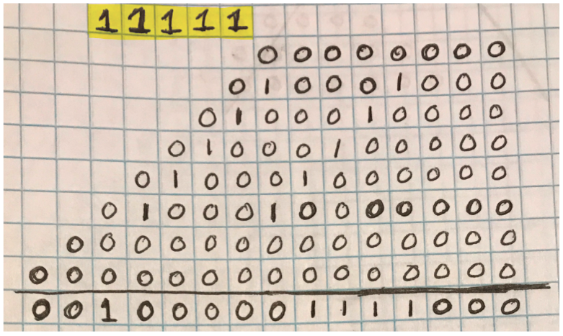

The picture above shows the carried bits highlighted in yellow. The picture above shows the summation of the smaller multiplication results of the 8-bit by 8-bit binary problem on the previous page. The summation results in the final result for the 8-bit by 8-bit binary multiplication equation.

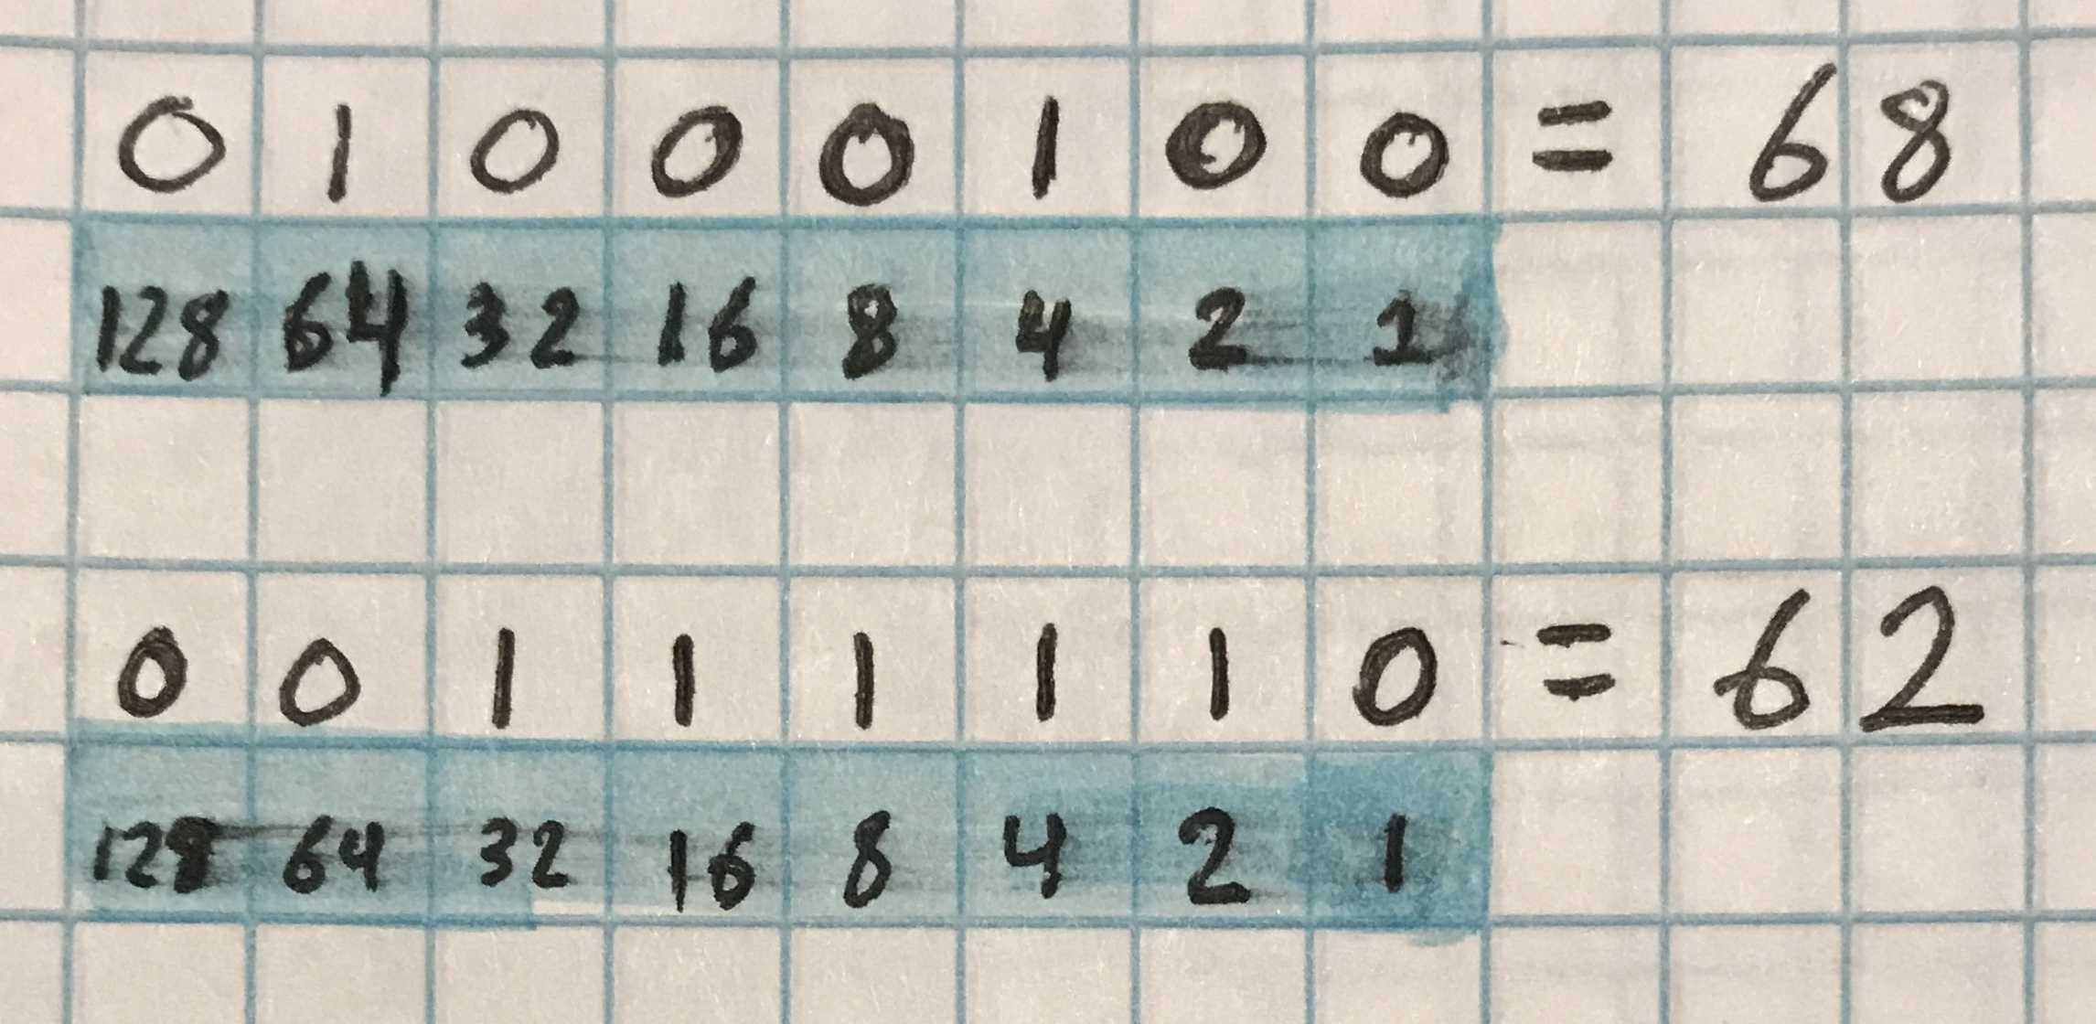

The above picture shows the binary to decimal conversion for the multiplier and multiplicand respectively.

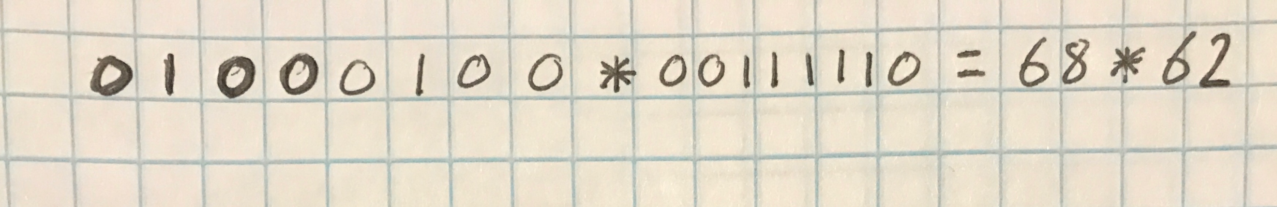

The above picture shows the binary to decimal conversion of the 8-bit by 8-bit binary multiplication equation.

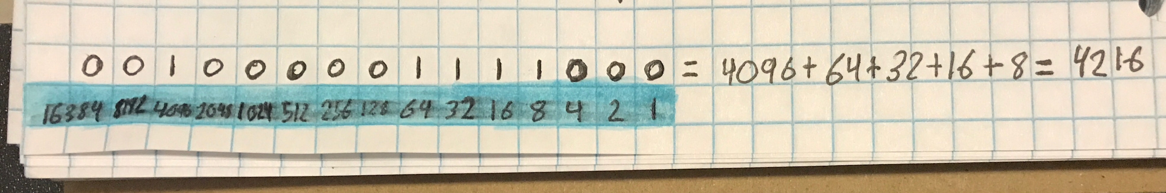

The above picture shows the binary to decimal conversion for the final result of the 8-bit by 8-bit binary multiplication equation.